Tugas Pendahuluan Modul 2

Nama : Helmi Efendi Lubis

NIM : 1301223338

Link github: <https://github.com/helmiel/pbo/tree/main/tp%20modul%202>

1. Fibonacci

Source code:

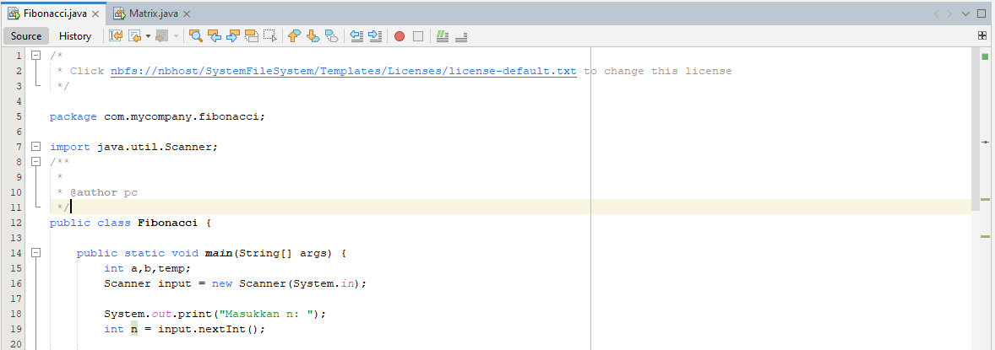

Output:

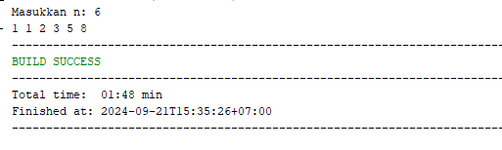

1. Perkalian Matrix

Source code:

Output:

